Online Grocery Delivery Application - ‘Carriage’

Business Requirements Document

Project: Online Grocery Delivery Application - ‘Carriage’

Author(s): Vihan Parmar, Mady Dembele, George Lopez, Roneil Boodram, Lang Gong, Tianqi Han, Maisha Masnoon, Jevon Cowell

Table of Contents

**Project Overview** **3**

**Document Information** **3**

2.1 Audience 3

**Business Opportunity** **4**

3.1 Project Overview and Background 4

3.2 Current State Analysis 4

3.3 Future State Objectives 4

3.4 Business Domain Model and Stakeholders 5

**Business Requirements** **6**

4.1 Details of Business Requirements 6

**Non-Functional Requirements** **8**

**External Data Feeds** **9**

**Business Risks** **10**

# **Project Overview**

This document describes the business/user requirements for the Carriage applications that will provide the basis for the following project activities:

* Introducing business/user requirements
* Creating test plans and test specifications
* Identifying stakeholders
* Devising solutions to project tasks
* Produce an application that will enable users to shop groceries online and get them delivered at doorstep
* Determining when the project is complete
* Assessing the degree to which the project succeeded

# **Document Information**

## 2.1 Audience

|  |  |  |
| --- | --- | --- |
| Name | Business Group | Role |
| Advertising Media | Advertisement Sales Management | Partner/Supplier |
| Grocery Stores, supermarkets | Stores Management, User Support Team | Partner/Supplier |
| Delivery Persons | Delivery Management | Partner/Supplier |
| Credit Card Vendors | Subscription / Account Management | Partner/Supplier |
| Geolocation Vendors | Subscription / Account Management | Partner/Supplier |
| Unregistered Customers | Advertisement Sales Management, User Support Team, Stores Management, Subscription / Account Management, Delivery Management | Application Users |
| Register Customers | Advertisement Sales Management, User Support Team, Stores Management, Subscription / Account Management, Delivery Management | Application Users |
| Participating Grocery Stores | Advertisement Sales Management, User Support Team, Stores Management, Subscription / Account Management, Delivery Management | Application Users |
| Register Delivery Persons | User Support Team, Subscription / Account Management | Application Users |

# **Business Opportunity**

## 3.1 Project Overview and Background

Our goal is to create an online grocery shopping mobile application named Carriage that will provide pickup and delivery services to customers.

The application will provide users with a user-friendly interface that will allow register customers to set their location and see local participating Grocery Stores and superMarkets and select a vendor to view an assortment of available products that they can order, be able to add or remove these items to their cart and checkout once they’re ready. On the checkout page, before confirming their order, register customers will select a Delivery time and will be offered exclusive online pricing for Subscribe members and faster delivery times depending on the order for Premium Subscribe members. After a successful transaction, register customers will be presented a confirmation screen with the ability to Track Their Order and write a review of their shopping experience.

On the other side, the App will allow register delivery persons to accept or decline orders and interact with customers for clarification and order statuses. The delivery persons should also be able to accept multiple orders for the same store and be provided with an Overview Map of the store to find items.

And lastly the app will allow registered grocery stores to submit promotions for premium/normal subscribers to use.

## 3.2 Current State Analysis

The 2020 COVID-19 pandemic has changed human culture and society in so many ways. Tasks as simple and straightforward as going to the grocery store have now become more time consuming, stressful, dangerous for certain at-risk populations. The Carriage app is aimed to mitigate these stressors and provide a much more time-effective, effortless, and safe means of supplying everyday people with the groceries they need. By working with a network of grocery stores, delis, and other food vendors, along with a network of delivery drivers, Carriage will allow safe, fast deliveries of groceries to end-users via a very user-friendly and intuitive app. We estimate that due to the current state of many people working from home, and the uncertainty as to when the pandemic will end, now will be an ideal time to bring forward this application and business model to the general public. Apps such as UberEats have already been able to successfully deliver meals from restaurants, but the pandemic has created a vast audience in need of safe deliveries for groceries. The project will be created with React Native and will use a relational database MySQL. The development of this application has already begun, and will be finalized in the following semester at Pace University (Fall 2021).

## 3.3 Future State Objectives

The objective of this application is to create a long-term profitable service that can be of significant benefit to society during a very challenging time. By using the current environment of the pandemic, we believe we can distinguish Carriage from over delivery-based applications and create a sustainable grocery delivery model that can last even after the pandemic. Some of our additional objectives include utilizing Carriage as a paid advertising platform as our popularity grows, improving GUI friendless and correcting glitches as reported, and expanding the network of vendors and delivery drivers. We believe that by adding a variety of vendors that offer diverse and nutritious foods, we can significantly expand our base of customers.

## 

## 3.4 Business Domain Model and Stakeholders

|  |
| --- |
| Stakeholders |
| Client support team |
| Marketing team |
| Subscription/account management team |
| Grocery stores and supermarkets |
| Geolocation service provider companies |
| Advertising media agencies |
| Unregistered Customers |
| Registered customers including, but not limited to - working individuals, families, young adults, etc. |
| Packaging materials suppliers |
| Delivery persons/delivery service companies |
| Credit card vendors |

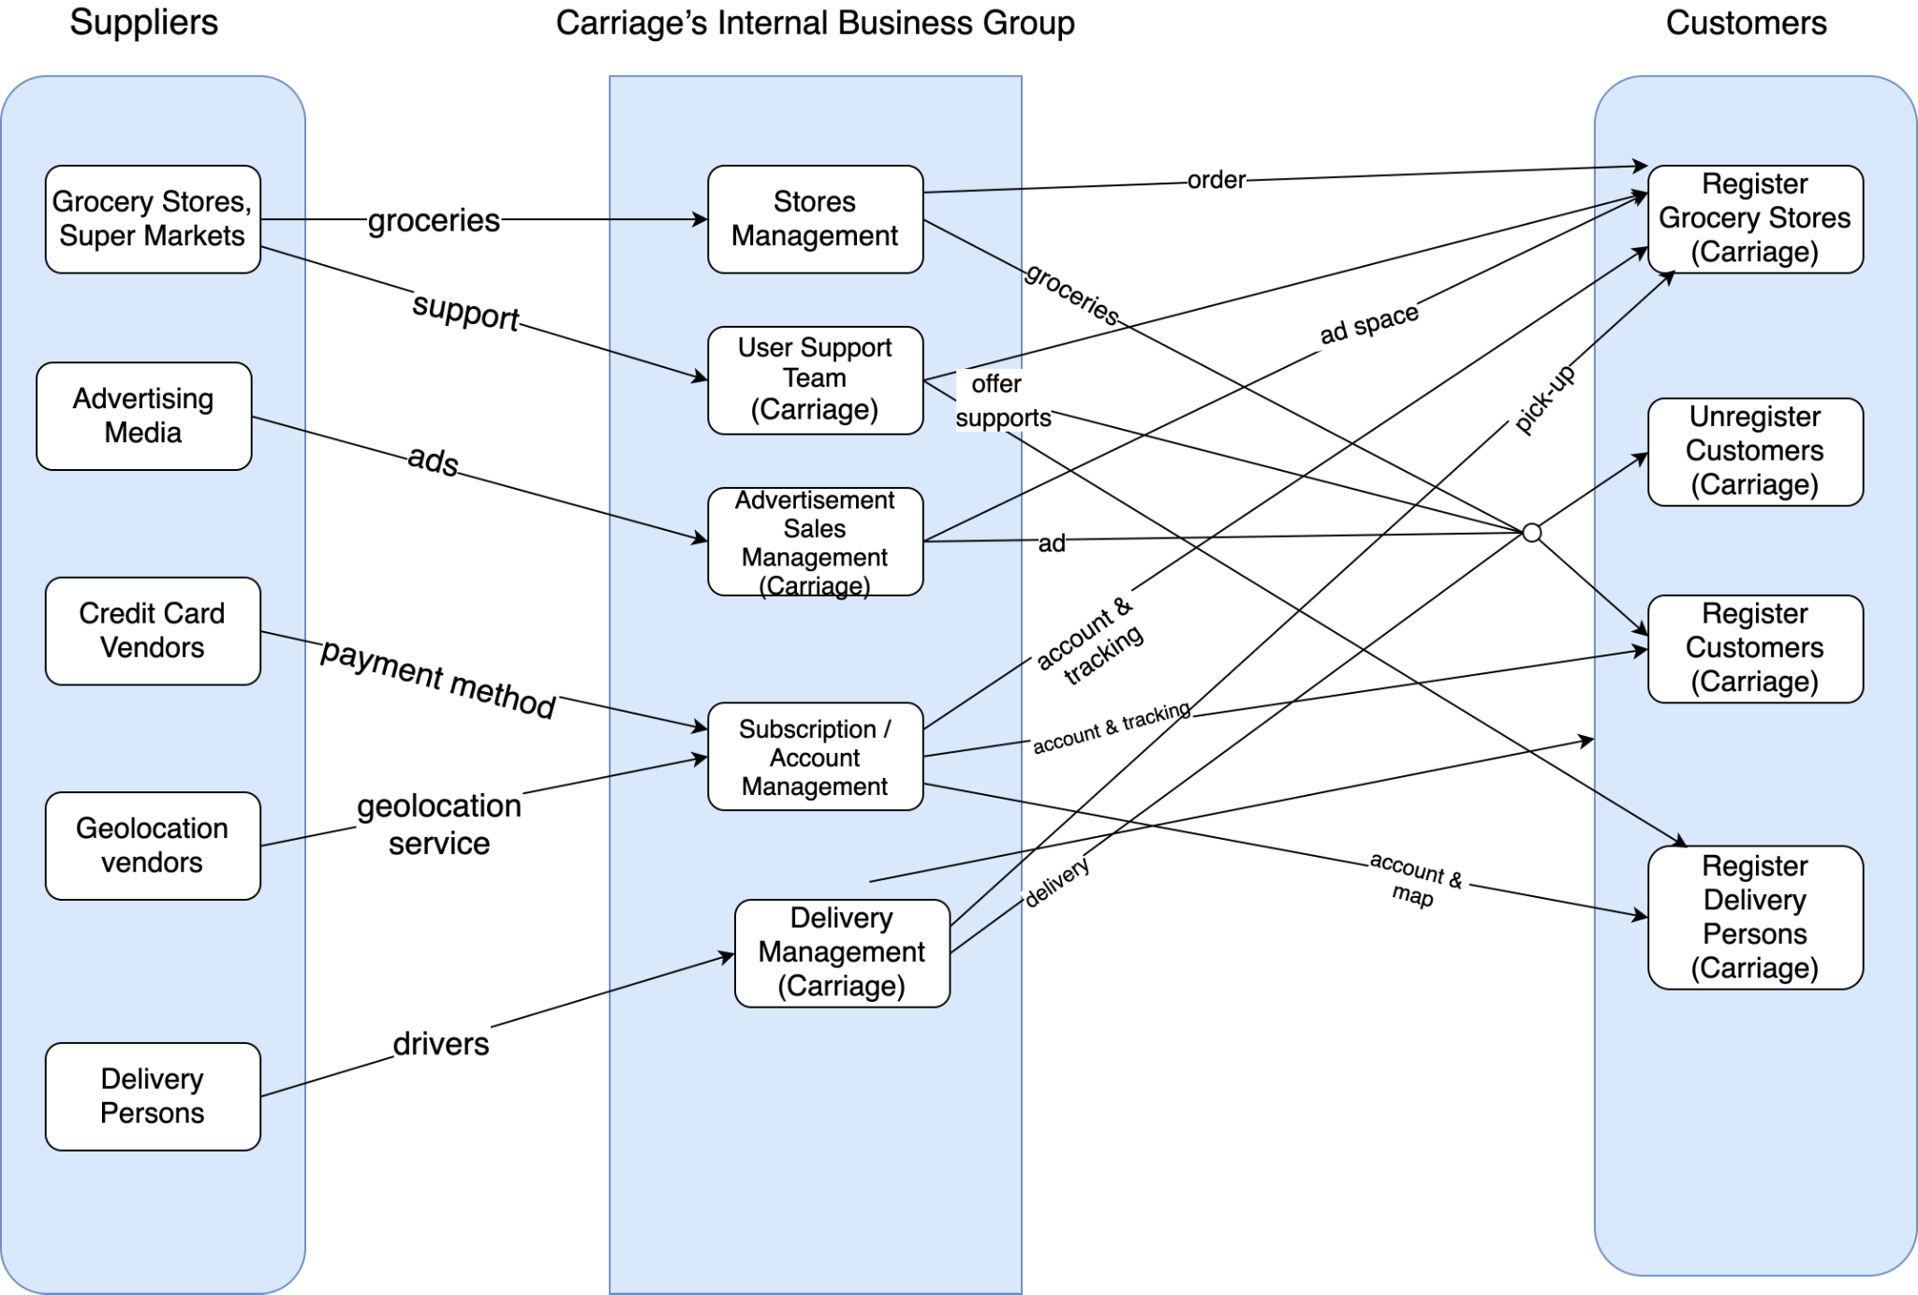

# **Business Requirements**

The Online Grocery Delivery Application - ‘Carriage’ will be able to provide convenient pickup and delivery services to customers. It will provide advertisements to customers for propagating products. Allowing customers to create their personal accounts and subscriptions, and allow them to choose a variety of payment options, such as Credit cards, Debit cards, Google Pay, Apple Pay and so on. Customers can add or delete products in the orders, track the orders by tracking numbers, and they have the right to cancel the orders. Delivery persons can use maps provided by Carriage and receive labor fees. The Internal Business Group of Carriage will be able to manage and supervise the actions of orders at any time, detect and solve the problems of orders on time.

## 4.1 Details of Business Requirements

* + 1. **Advertisement Sales Management** 
       1. Ability to log in
       2. Ability to generate ads on the web application
       3. Ability to maintain content of an ad
       4. Ability to create contents of digital banners and coupons
       5. Ability to finalize the pricing of ads
       6. Ability to filter ads content
       7. Ability to keep ads up to date
       8. Ability to do market research on different advertisement sales techniques
       9. Ability to build and execute social media strategy through competitive research
       10. Ability to understand product performance
       11. Ability to promote sponsored posts
       12. Ability to strategize and maintain any social media campaign
    2. **User Support Team**
       1. Ability to troubleshoot technical issues
       2. Ability to create customer service tickets and resolve customer complaints
       3. Ability to facilitate the communication between end users
    3. **Delivery Management**
       1. Ability to log in
       2. Ability to send the confirmation that order is being prepared
       3. Ability to send the confirmation that the order is ready for delivery
       4. Ability to send the tracking number when order is shipped
       5. Ability to send the confirmation that the order was delivered
       6. Ability to submit the price per subscription plan
       7. Ability to manage the containers of the specific subscription plan
    4. **Participating Grocery Stores Requirement** 
       1. Ability to log in
       2. Ability to put items for sale on the store page
       3. Ability to discontinue the sale of items
       4. Ability to update product information (images, descriptions, prices, etc.)
       5. Ability to change the status of items (in stock, out of stock)
       6. Ability to receive customer orders
       7. Ability to send the confirmation that order is being prepared
       8. Ability to see order information and delivery person information
       9. Ability to see and respond to customer comments
       10. Ability to cancel account
    5. **Unregistered Customers Requirements**
       1. Ability to browse vendors
       2. Ability to browse vendor listings
       3. Ability to view local vendors
       4. Ability to create an account
    6. **Registered Customers Requirements** 
       1. Ability to create an account
       2. Ability to delete the account
       3. Ability to modify the account information
       4. Ability to restore the password/user ID details
       5. Ability to sign in to (sign out from) already created account
       6. Ability to select the subscription plan
       7. Ability to pause the subscription plan
       8. Ability to read the product information
       9. Ability to add/remove items to/from the subscribed box
       10. Ability to cancel the order before it is prepared for shipping
       11. Ability to create profile of liked/disliked ingredients
       12. Ability to skip a future order delivery
       13. Ability to view the orders history
       14. Ability to enter/modify the delivery address
       15. Ability to provide the additional delivery instructions
       16. Ability to enter/modify the payment information
       17. Ability to submit the form to customer support
       18. Ability to read the resolution of the opened ticket with customer support team
       19. Ability to share the product on social media
       20. Ability to make product favorite
       21. Ability to view the list of favorite products
       22. Ability to leave the reviews
       23. Ability to rate the products
    7. **Registered Deliverers Requirements** 
       1. Ability to create an account
       2. Ability to modify the account information
       3. Ability to restore the password/user ID details
       4. Ability to sign in to (sign out from) already created account
       5. Ability to receive customer orders from participating Grocery Stores
       6. Ability to accept or decline orders
       7. Ability to accept multiple customer orders form the same store.
       8. Ability to interact with customers and grocery store for orders clarification & statuses
       9. Ability to view your delivery history
       10. Ability to leave Deliverers reviews
       11. Ability to delete the account

# **Non-Functional Requirements**

|  |  |
| --- | --- |
| **Category** | **Requirements** |
| **Usability** | The application GUI will provide a user-friendly intuitive design with all the features clearly displayed for the user |
| **Usability** | The application navigation will be self-explanatory by clear and concise descriptions and names of each section, as well as features will be clearly evident by proper location and naming |
| **Usability** | Accessibility will be supported for the disabled users as well |
| **Performance** | The application will be supported on different operating systems and browsers, and should not impact the user’s system capabilities |
| **Performance** | The application will be available for 24/7 without any interruptions, and regular maintenances will be scheduled to support the application |
| **Performance** | The application will support the concurrency where the users will be able to simultaneously browse the app, login & subscribe, make payments, shop the products |
| **Performance** | The application will have short response time to all requests and all the features should be available and not impacted by latency |
| **Security** | The application will be using the automated daily & weekly audits to detect the vulnerabilities. |
| **Security** | The application will use HTTPS protocols for any data exchanges, enforced TLS for all the email communications, and other encryptions that will be maintained on the server |
| **Database** | The application will be using MongoDBB |
| **External System** | The application will be able to interface with the external data feeds from and to payment merchants, ad agencies, social media websites, etc… |

# 

# **External Data Feeds**

* **Processing insurance claims** 
  + In the event an incident occurs that may be of significant financial loss to the company, it is very important we have insurance coverage from insurance brokers. Having adequate insurance policies in place will prevent financial loss from lawsuits and cybersecurity breaches the company may experience. Insurance claims against the company will be paid in accordance with settlement of the dispute. Multiple insurance brokers will be utilized based on the specific coverage offered.
* **Providing digital advertising**

In order to expand awareness of the Carriage application, we will utilize external social media platforms to display advertisements. Ads for Carriage will be visible on various social media platforms (i.e - Twitter, Instagram, Facebook, etc.). Any updates made to the application overtime can be changed in real-time to reflect the marketing goals of the Carriage application team. Utilizing popular social media platforms during the launch of the Carriage app can help build a larger audience for the services provided (i.e. grocery deliveries).

* **Providing legal counsel for contracts and lawsuits**

Having a robust legal counsel, composed of attorneys who specialize in small business and compliance law/regulation, will be essential for the long-term sustainability of Carriage. Legal counsel can help draft policies and contracts in compliance with local/federal laws. In addition, legal counsel can represent the company with lawsuits that are for/against the company. We anticipate that legal discrepancies will arise due to the multiple end-users who will utilize this application, and the many rules and regulations that must be followed when having a small business.

* **Processing Credit / Debit Card Payments**

Credit / Debit cards from banks will be the primary option for payment while using the Carriage app. Banks will be utilized to process the payment information from credit/debit cards. Credit /debit card transactions will be accurately reflected in the accounts of all end-users. Prompt payments to/from end-users for payment will be an essential complement of the Carriage app. We anticipate being able to expand to more banks as the audience of this application continues to grow.

# **Business Risks**

Carriage’s primary focus is to provide a means by which users can search and order desired grocery items from local vendors within an intuitive, hassle-free mobile application. The “Food-Delivery” market is a growing sector with various already well-established competitors. The most significant risk for Carriage lies in losing external stakeholders to these competitors. As a means to migrate against this risk, Carriage plans to ensure its user interface meets all the requirements necessary for end-users, vendors, and drivers to perform their desired action. If a bug or missing feature impedes such from happening, multiple avenues of communication for feedback should be available. Ensuring that external stakeholders are feedback is heard, discussed, and replied to in a timely fashion is a big step in ensuring that Carriage is their primary business choice for Grocery Delivery apps. The Scrum framework should ensure that Carriage can timely implement new features to keep and attract new and old stakeholders.

To function, Carriage utilizes several open-source third-party software. As with any company, such software runs the risk of malfunction and vulnerabilities. To migrate against “upstream compromises, such as package hijacking and typo-squatting,” companies often use Private Package Feeds (PPF). But even PPfs are vulnerable to attacks via the substitution attack[1]. As a means of combating this vulnerability, Carriage plans on utilizing version-pinning[2] and integrity verification[3] for all of its package managers. [4]

Access Control is an essential element in every software level and will be fully utilized in Carriage to migrate against unauthorized access of Carriage systems. All internal staff will be required to use non-SMS-based 2-factor authorization to access internal systems. To protect stakeholders and employees against potential Data Breaches, Carriage will ensure all sensitive data is encrypted and backed up. All systems will be logged to Audit Logs to provide the ability to audit unauthorized access of systems by internal and external actors. Audit Logs will also be subjected to versioning to migrate against tampering.

API dependency is another significant risk for Carriage. Unexpected changes to 3rd Party APIs can have a detrimental effect on user-experience, from making certain in-app features unavailable to crashing the entire application if not handled correctly. To migrate against this risk, Carriage plans to implement extensive error-handling client-side and server-side. The goal is to ensure that end-users are not interrupted from their experience as much as possible, and in the event where such is not possible, explain to the user that the service will be back soon. Server-side, the goal is to ensure that Carriage’s developers can quickly troubleshoot and report 3rd-Party API issues separate from in-house bugs.

1. “[When] an attacker discovers that a client is using a private package that’s not present on the public feed. After the attacker uploads a higher version of the private package to the feed, the client downloads it automatically because it has the same file name. Services that merge package feeds also allow this substitution if packages from public sources may override those from private sources. A related risk with a similar impact can emerge if the package publisher’s credentials have been compromised.” (Microsoft, 2021)
2. “Specifying precise versions for packages and transitive dependencies...” (Microsoft, 2021)
3. “ensures that a downloaded package is identical to the first time it was downloaded and will abort if any inconsistencies are detected” (Microsoft, 2021)
4. Microsoft. (2021, 2 9). 3 Ways to Mitigate Risk When Using Private Package Feeds. *Secure Your Hybrid Software Supply Chain*.